Buddhika S. Ranasinghe

[Buddhikasranasinghe96@gmail.com](mailto:Buddhikasranasinghe96@gmail.com)

0712447339

**Question 1**

**Task :** “Martha Restaurant” is a famous restaurant offering a variety of food. The following is their menu. A customer first orders a main dish. Then he must order one or more side dishes. He may or may not order desserts.

**Project Link :** https://github.com/buddhikasranasinghe/ProgrammingTest.git

**Technologies :** Django, MySql, Bootstrap, JQuery

**DB name :** martharestaurent

**Interfaces :**

1. . Interface of ordering foods
2. . Interface of Information about Foods, and Revenue
3. 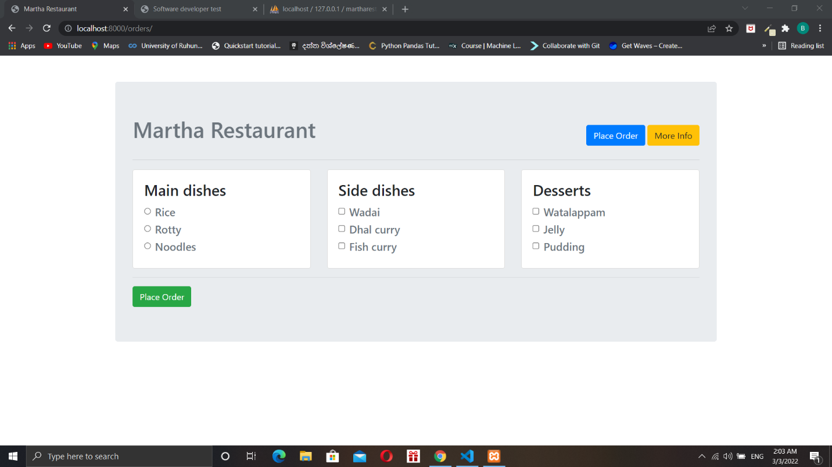. Display an errors with wrong input

(01)

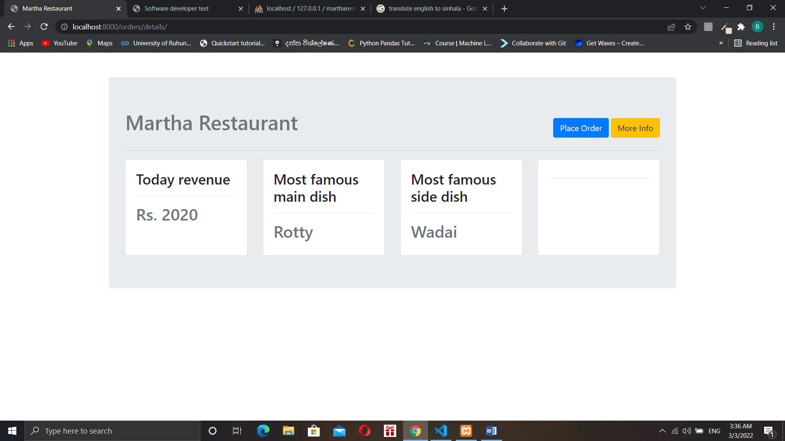

(02)

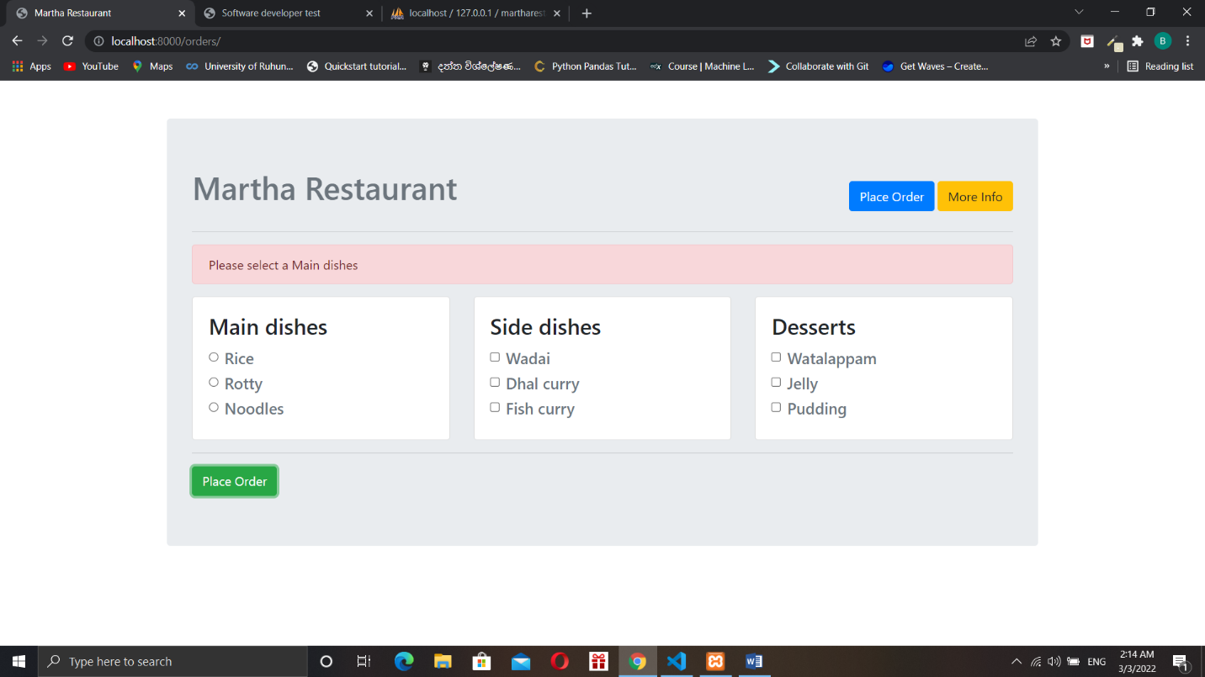**Display Errors :**

(03)

**Routes :**

<http://localhost:8000/orders/> -> ( 01 ) interface

<http://localhost:8000/orders/details/> -> ( 02 ) interface

**Er-diagram**

Maindishesh_id

FoodName

Amount

FoodName

Date

FoodName

ID

FoodName

Orders_revenue

Maindishesh_id

FoodName

FoodName

FoodName

ID

FoodName

Orders_desserts

Maindishesh_id

FoodName

FoodName

FoodName

ID

FoodName

Orders_sidedishesh

Orders_maindishesh

ID

FoodName

FoodName

FoodName